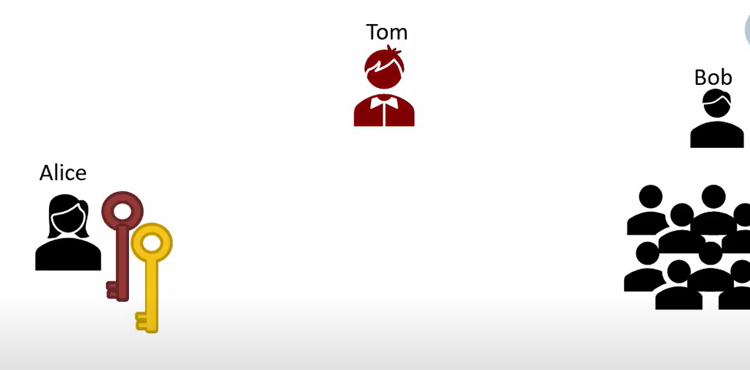
Alice has a pair of pub-sec keys and wants to send pub key to Bob

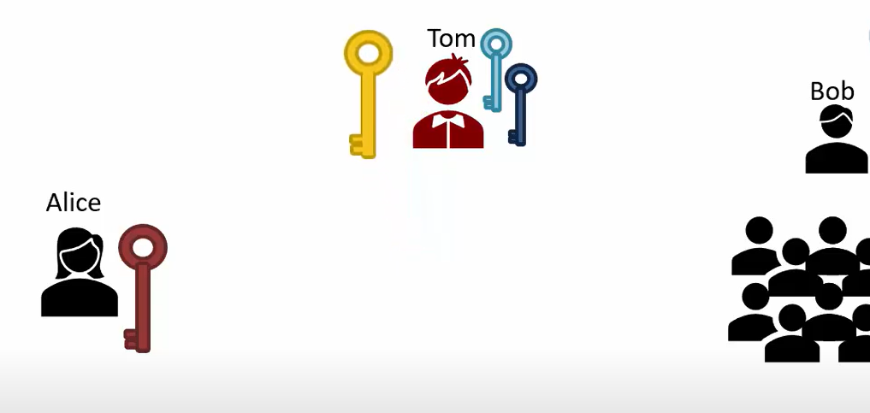
Tom get Alice’s pub key -> give Tom’s pub key to Bob -> Big issue

========================= Certificate =========================
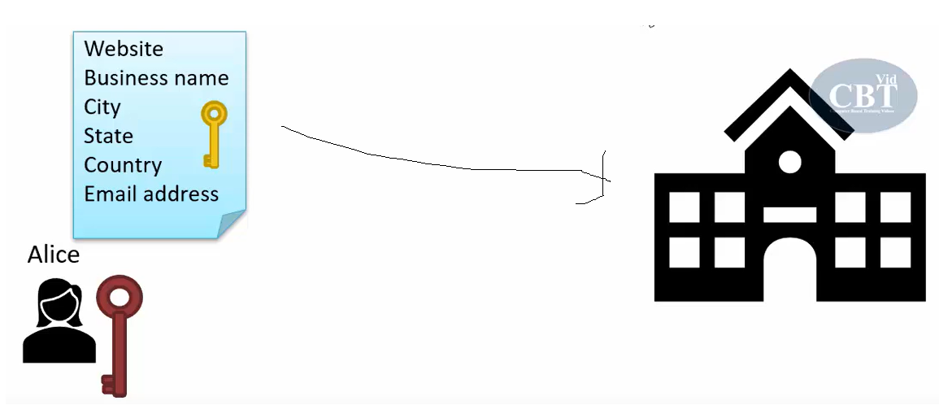
Alice -> create a Certificate signing request (CSR) -> CA

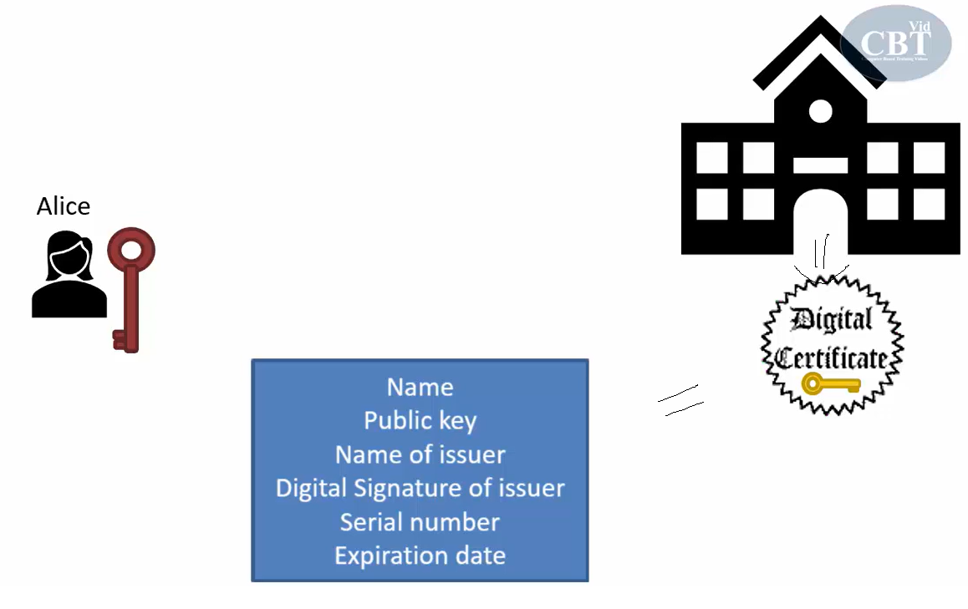
CA -> create a digital certificate (signature signed by CA’s priv key)

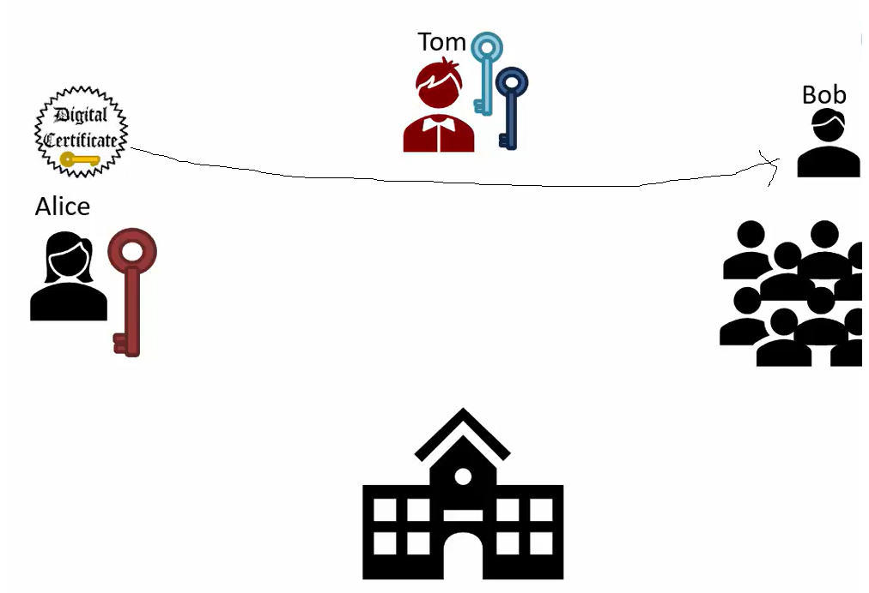
Alice -> send this digital certificate to Bob

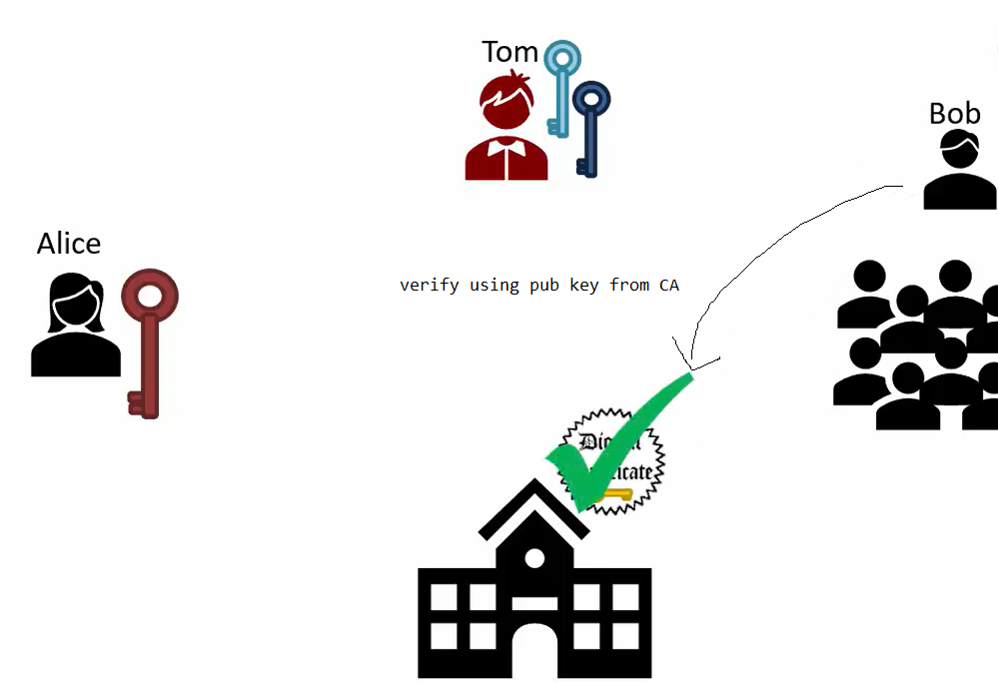
- Now Bob is sure that pub key (yellow) is actually Alice’s

